AngularJS Assignments

1. Write a generic angular factory that can communicate with server side RESTful APIs & perform all major HTTP operations like GET, POST, PUT & DELETE on any entity.
2. Build the application that performs CRUD operations with Product entity using REST calls. Note the application should have a single shell page & multiple view pages. You may use REST server running your local network.

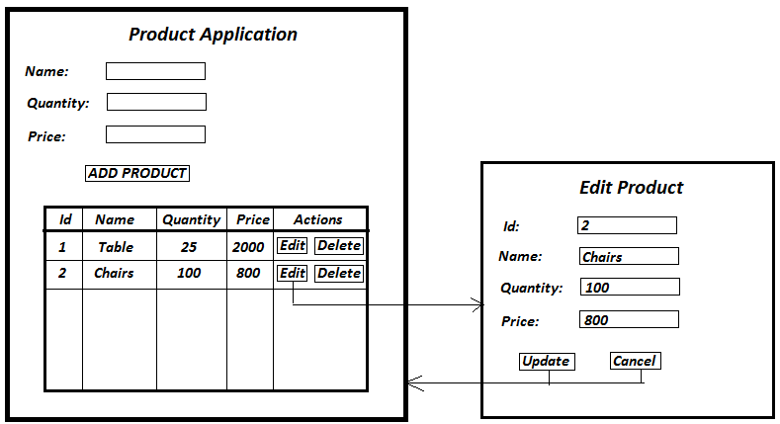

1. Write an element type (‘E’) custom directive called ‘ng-populate-table’ which retrieves all products from REST APIs & populates it inside a table. You may use REST server running your local network.
2. Write a generic custom filter that filters product list by id, name, price & quantity.
3. Write an application similar to quikr.com. Add following functionalities:

* User registration
* Login
* Logout
* Posting new advertisement, Deleting advertisement & Editing advertisement
* Searching advertisement
* Sending message to advertise owner that ‘You are interested’.

Note that it is a local application & does not communicate with any RESTful server. You may use a custom directive or custom filter, you have created in earlier assignments. Do not focus more on correctness of UI. However, add all UI validation using angular form validation directives. You may ignore ‘image’ field from UI since you are storing data in local storage. Also you need to create one shell page & others as view pages. Please find the screen shots below:

**Login screen:**

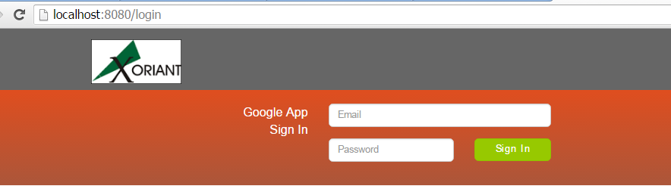

**Search advertises screen:**

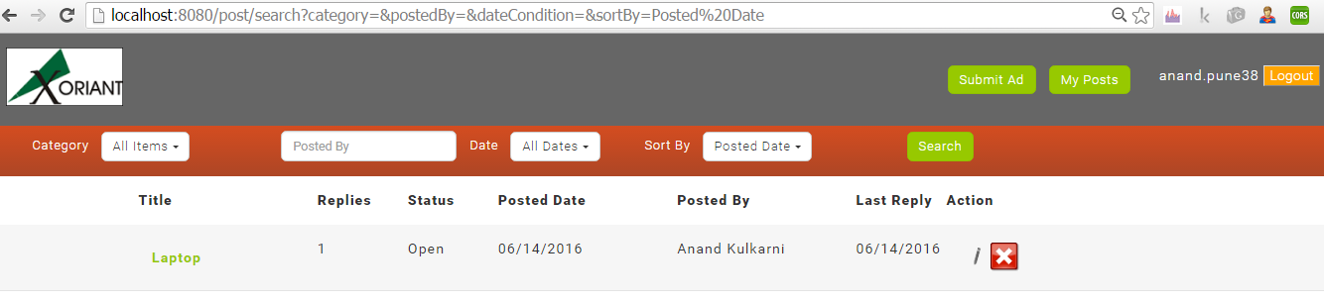

**List advertises posted by you:**

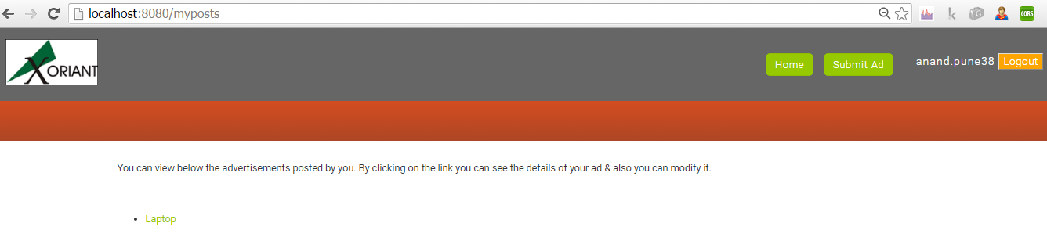

**Show advertise details or edit advertise screen:**

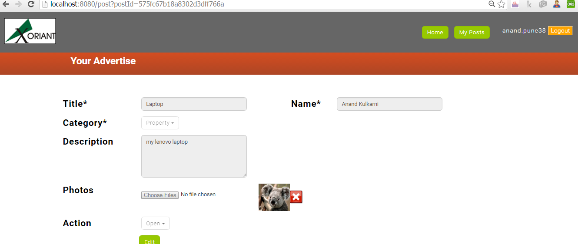

**Post new advertise screen:**

